**GROUP 2**

Bilal Ali- 665207

Jesse Okumu Mwangi- 673568

Gideon Mwaniki- 670711

Christterude Weber- 671703

Rashid Ismael Rashid- 673160

Nathan Madara- 672952

**PHP Code**

<!DOCTYPE html>

<html>

<head>

<title>Student Form</title>

</head>

<body>

<h2>Enter Student Details</h2>

<form method="post" action="student_form.php">

Student Name: <input type="text" name="studentname" required><br><br>

Student ID: <input type="text" name="studentid" required><br><br>

Date of Birth: <input type="date" name="dob" required><br><br>

Course ID: <input type="text" name="courseid" required><br><br>

<input type="submit" name="submit" value="Save">

</form>

<?php

error_reporting(E_ALL);

ini_set('display_errors', 1);

// Connection settings

$conn = new mysqli("localhost", "root", "", "studentdb");

// Check connection

if ($conn->connect_error) {

die("Connection failed: " . $conn->connect_error);

}

print_r($_POST)

if (isset($_POST['submit'])) {

$studentname = $_POST['studentname'];

$studentid = $_POST['studentid'];

$dob = $_POST['dob'];

$courseid = $_POST['courseid'];

echo "Name: $studentname<br>";

echo "ID: $studentid<br>";

echo "DOB: $dob<br>";

echo "Course: $courseid<br>";

$sql = "INSERT INTO Students (studentname, studentid, dob, courseid)

VALUES ('$studentname', '$studentid', '$dob', '$courseid')";

if ($conn->query($sql) === TRUE) {

echo "<p>Record saved successfully!</p>";

} else {

echo "<p>Error: " . $conn->error . "</p>";

}

}

$conn->close();

?>

</body>

</html>

**Webpage Output**

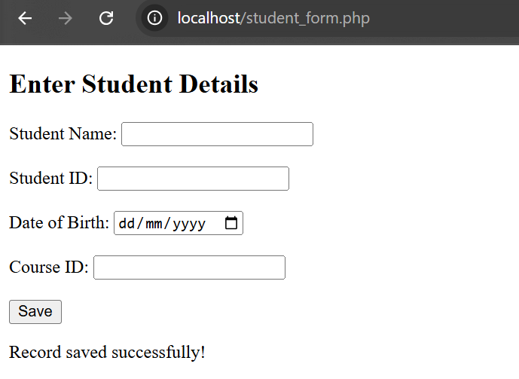

**MySQL Database Structure**

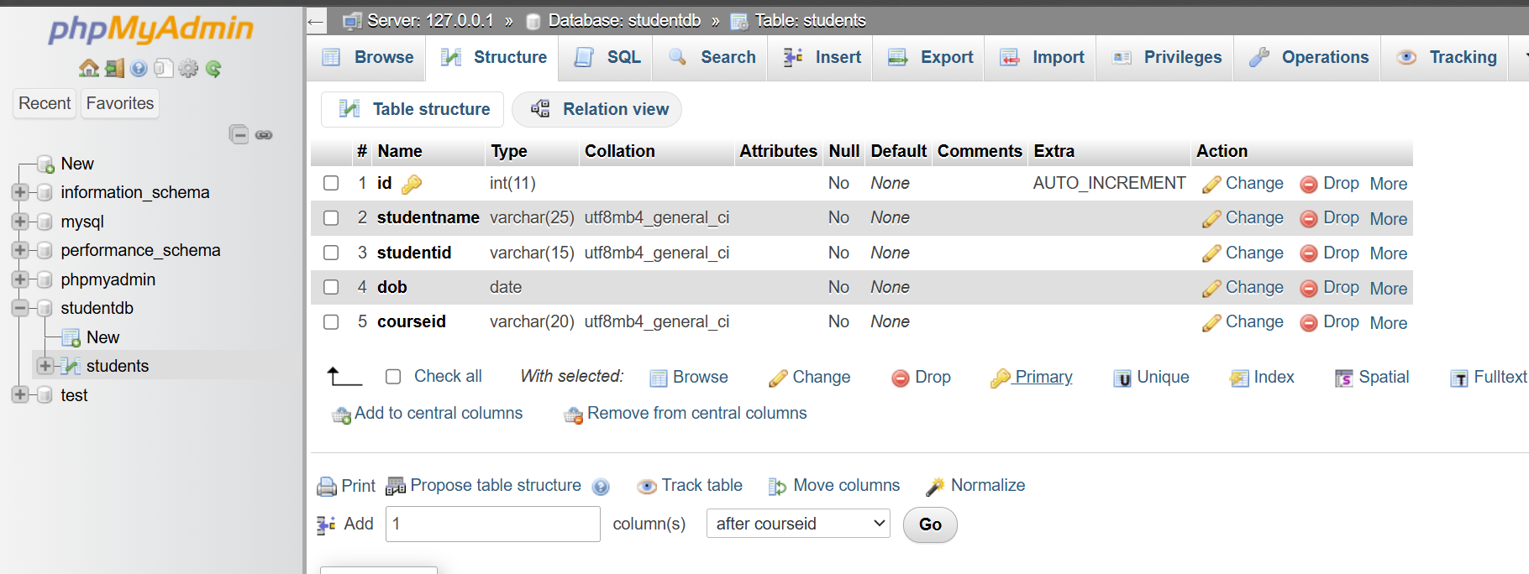

**MySQL Database records**

